Abstract— Face detection and image or video recognition are hot topics in biometrics research. Face recognition in real-time is a fascinating field with a rapidly growing challenge. Real-time face detection is not only a component of an automated face recognition system, but it is also becoming a separate research subject. As a result, there are several approaches to solving the problem of face detection . The researchers developed programming on OpenCV, Haar Cascade, LBPH, and Python to create a camera-based real-time face recognition system and set an algorithm. The results show that the dual-thread form of face detection is easier, faster, and more accurate.
Model-based Face Detection using OpenCV
^{[1]} Kenneth Von Golosinda, ^{[2]} Jasper Van Marcellones, ^{[3]} Audrey Nanual
^{[1]} Malayan Colleges Mindanao,^{[2]} Malayan Colleges Mindanao, ^{[3]} Malayan Colleges Mindanao
^{[1]} kvgolosinda@mcm.edu.ph,^{[2]} JvMarcellones@mcm.edu.ph, ^{[3]}AjNanual@mcm.edu.ph
Index Terms—Face Detection, OpenCV, Haar Cascade, NumPy

INTRODUCTION
A face recognition program is a piece of software that can verify a person's identity and identify him or her using a video or image from a source. The earlier work on facial recognition can be traced back to engineering literature for at least the 1950s and 1960s in psychology. Experiments on Darwin's feelings for facial expression are among the earliest findings. Intel has created an open source platform called OpenCV. (Media, 2008) Facial recognition is a simple and reliable process. The preferred facial features are one way from a face and an image database. It is used in security systems and thumb recognition systems, and is often compared to biometrics such as fingerprints and eye reconnaissance systems. Common recognition algorithms included key element analysis using Fisher face algorithms, the Markov model, multilinear subspace learning using tensor representations, and nervously driven dynamic reference matching, among others. The Intel open-source Computer-View library makes programming simple. This provides advanced facial detection, face tracking, and facial recognition capabilities, as well as a variety of ready-to-use artificial intelligence methods (AI). It has the benefit of being a multi-platform framework; it supports Windows, MacOS, and, more recently, Mac OS X.

OPEN CV V/S MATLAB

Speed
Since MATLAB is made up of Java, which is made up of C. When a script is scripted and executed on MATLAB, the computer first interprets the code and converts it to java before finally executing the script. Open CV, on the other hand, makes use of C/C++ and/or python library functions. This provides the computer with machine language code directly, allowing for faster execution. Using OpenCV saves time and money by focusing on image processing rather than interpreting.

B. Portability

Since OpenCV is written in C, it can be run on any computer that can run C. It fits well with Windows, Mac OS X, and Linux.

C. Cost
OpenCV is much less costly than MATLAB. OpenCV is free, while MATLAB costs about USD2150. Even the most basic version of MATALAB is costly due to its commercial, single-user license. OpenCV is also free since it is licensed under the BSD license.

NumPy Array Structure: A View on Memory

A NumPy array—also called an “ndarray,” short for N-dimensional array—describes memory using the following attributes:

• data pointer: the memory address of the first byte stored in the array;

• data type description: the kind of elements contained in the array, such as floating-point numbers or integers;

• shape: the array’s shape, such as (10, 10) for a 10 × 10 array, or (5, 5, 5) for a block of data describing a mesh grid of x-, y-, and z-coordinates; • strides: the number of bytes skipped in memory to proceed to the next element along a given dimension (for a (10, 10) array of bytes, for example, the strides might be (10, 1), or proceed one byte to get to the next column and 10 bytes to locate the next row); and

• flags: define factors such as whether we’re allowed to modify the array or whether memory layout is C- or Fortran-contiguous (in C, memory is laid out in “row major” order— that is, rows are stored one after another in memory—whereas in Fortran, columns are stored successively).

NumPy’s strided memory model deserves particular attention, as it provides a powerful way of viewing the same memory in different ways without copying data.

Face Algorithm

Face Detection using Haar Cascade
A haar cascade is defined as a set of "square-shaped" functions that together form a wavelet family or base. It also focuses on "Haar Wavelets," which divide pixels in a picture into squares using a haar wavelet approach proposed by Paul Viola and Michael Jones in their 2001 paper "rapid object detection using an enhanced cascade of simple features" (P.Viola, 2010). It's a computer-based learning method

that employs a large number of positive and negative representations to build a cascade function. After that, it's used to detect objects. To compute "features" identified by the hair cascades, "integral image" principles were used.
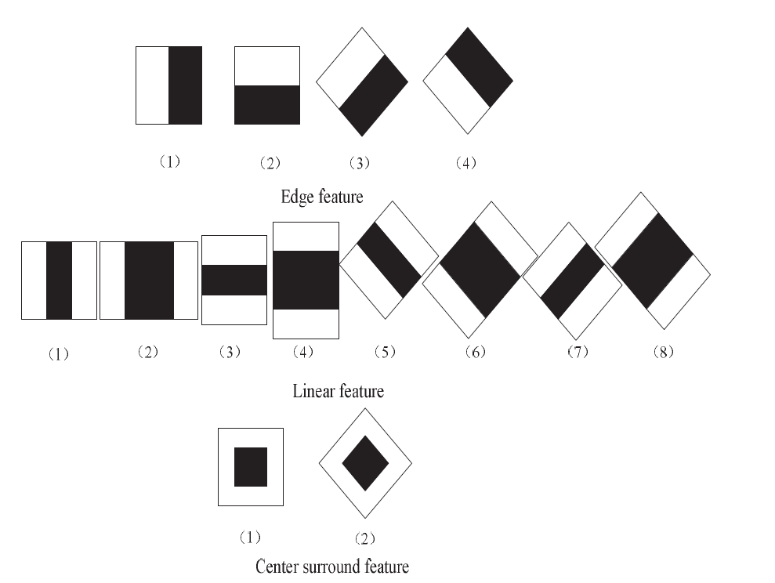

Fig 4.1-Extraction features in Haar-like features.

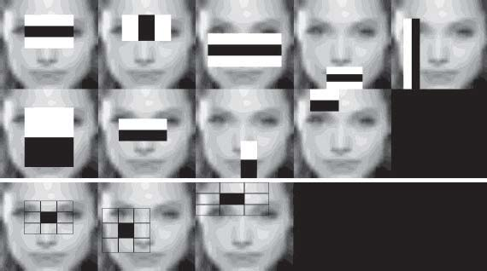
Fig 4.2-Haar cascade classifier view

To find it, the cascade is multiplied by 1.25 and different sized faces are repeated. Running an image on cascade consumes a significant amount of computing power and time.

B-Face Recognition Using LBP

Local Binary Pattern (LBP) Is an easy, but very strong user of texture who marks the image's pixels with each pixel's proximity, and views the outcome as binary numbers.

It was first defined in 1994 (LBP) and is a powerful component for the classification of texture since then. In addition, LBP has been calculated to increase significantly the detection efficiency on certain datasets when coupled with histograms of oriented gradients (HOG) descriptor. By using LBP combined with histogram, face pictures with a simple data vector can be described.

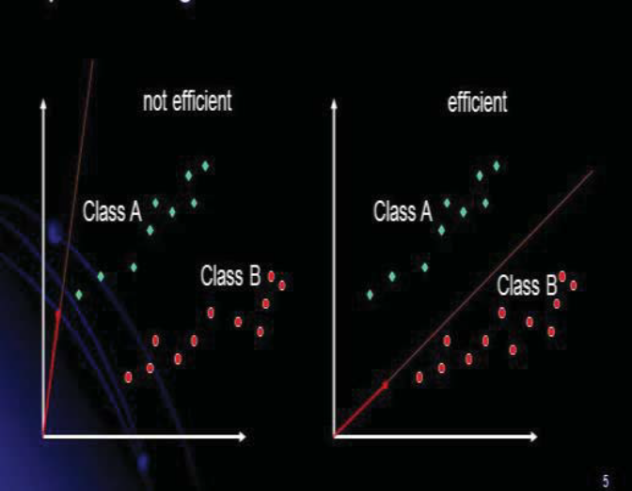
Fig 4.3-PCA seeks directions that are efficient for representing the data.

Local Binary Patterns, or LBPs for short,the work popular of Ojala et al as texture descriptor in its 2002 paper, Multiresolution Grayscale and Rotation Invariant Texture Classification with Local Binary Patterns (the definition of LBPs was implemented at the beginning of 1993). It computes a global representation of texture based on the Gray Level Co-occurrence Matrix, unlike Haralick. LBPs compute a regional texture representation. The binary image is built by comparing every pixel with the pixel surrounding area. For example, look at the original 3 x 3-pixel neighborhood LBP descriptor operated just same this:

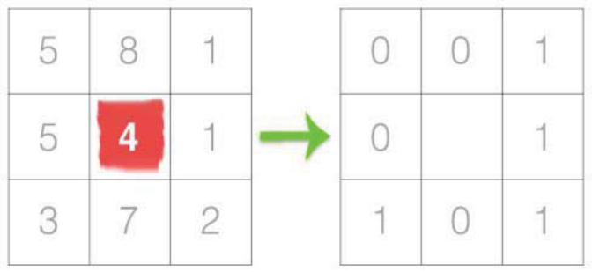
Fig 4.4- Binary Pattern

A middle pixel and an 8-binary numbers cap are the first step in creating an LBP for the 8 Pixels neighborhood. In the figure above, we choose the center pixel and set it against its 8pixel neighborhood. If the pixel center is more than the following line, set the value to l; set the value to 0, otherwise. A total combination of 2 ^8= 256 possible LBP codes with eight pixels will be achieved. Thanks to a neighborhood of 3x3, we have 8 neighbors on which we must check binarily. This binary search results were stored in an 8-bit array and converted into decimal.
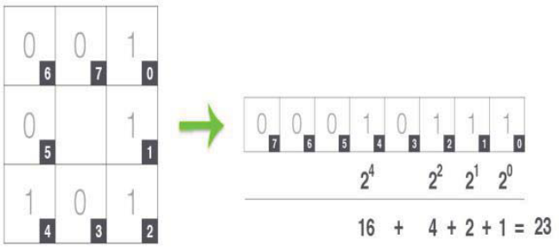
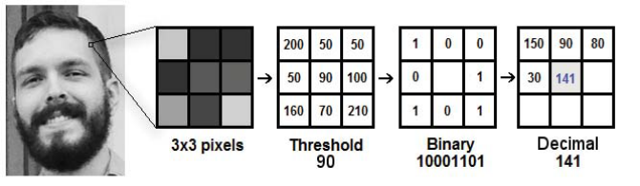
Fig4.4- Face Recognition of LBPH Algorithm

OPENCV STRUCTURE AND CONTENT

OpenCV is divided into five major components, four of which are depicted in Figure. The key picture processing and lower computer vision algorithms are found in the CV portion.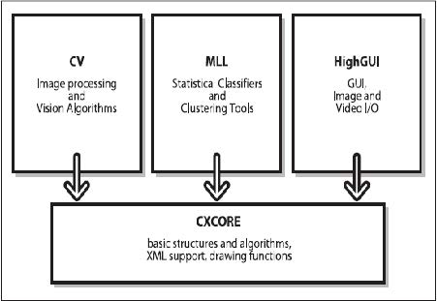
Fig 5.1 OPENCV Structure and content

FACE DETECTION WITH DUAL-THREAD

Face Detection with Dual-thread

A thread is a unit of execution in a process. All threads in a process are in the process' virtual address space and share the same virtual address space, global variables, and machine resources[10], making communication between threads easier. Furthermore, multi-threading is a general, functional form of parallel processing that prevents the use of the CPU for long periods of time.

This experiment's key thread is used to incorporate a cascade classifier, which also refers to the OpenCV file "haarcascade frontalface alt2.xml." The camera then begins to enter the video stream, resulting in the formation of a sub-thread. Meanwhile, each image frame is captured and shown in a separate thread. The time periods between the beginning and end of detecting a face are used as latency in order to screen video fluently.

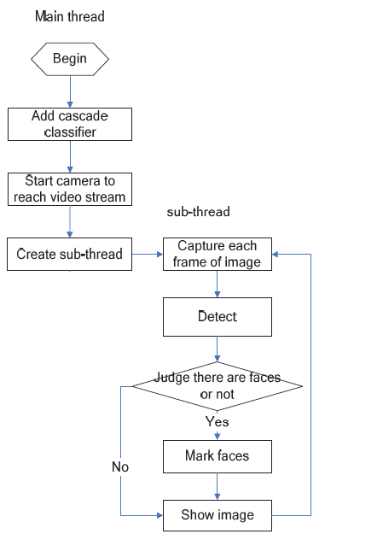

Fig 5.2 The flow chart of system

CONCLUSION
Facial recognition technology has come a long way in the last 20 years. Today, identity information can be checked automatically for secure transactions, monitoring, surveillance, and building access control. Such systems are typically used in controlled environments, and recognition algorithms can exploit environmental constraints to achieve high recognition accuracy. Face-recognition systems of the next generation, on the other hand, will be widely used in smart environments, where computers and machines will serve as supporting assistants.

RECOMMENDATION
There are some significant issues in face recognition. One difficulty is to prepare the image before using the tool. For instance, one of the capabilities is the ability to determine if an image is of a man or a woman, allowing an image to be classified by one or two classifiers and trained with such a person. When multiple spaces are spectrum-scale individuals in one section, it may be possible to achieve consistency in classification. This turns out to be a series of oddities for both men and women. The new classification network is a new piece of work that will be developed further in the future. Instead of projecting the resulting image into face space, you can build your network as an output from the data. It's possible that learning face projection increases the neural network classifier's accuracy.

REFERENCES
- Zhang, Shifeng, Cheng Chi, Zhen Lei, and Stan Z. Li. 2019. “RefineFace: Refinement Neural Network for High Performance Face Detection.” arXiv.
- Hsu, Rein Lien, Mohamed Abdel-Mottaleb, and Anil K. Jain. 2002. “Face Detection in Color Images.” IEEE Transactions on Pattern Analysis and Machine Intelligence.
- Or, Charles C.F., and Hugh R. Wilson. 2010. “Face Recognition: Are Viewpoint and Identity Processed after Face Detection?” Vision Research.
- Rosebrock, Adrian. 2017. “Deep Learning with OpenCV.” on August.
- Ismael, Khansaa Dheyaa, and Stanciu Irina. 2020. “Face Recognition Using Viola-Jones Depending on Python.” Indonesian Journal of Electrical Engineering and Computer Science.
- Guo, Guanjun et al. 2020. “A Fast Face Detection Method via Convolutional Neural Network.” Neurocomputing.
- Elsayed, Ahmed A., and Waleed A. Yousef. 2019. “Matlab vs. OpenCV: A Comparative Study of Different Machine Learning Algorithmsi.” arXiv.
- Chun, Lin Zheng et al. 2020. “YOLOv3: Face Detection in Complex Environments.” International Journal of Computational Intelligence Systems.
- Naveenkumar, M, and V Ayyasamy. 2016. “OpenCV for Computer Vision Applications.” Proceedings of National Conference on Big Data and Cloud Computing (NCBDC’15).
- Domínguez, César, Jónathan Heras, and Vico Pascual. 2017. “IJ-OpenCV: Combining ImageJ and OpenCV for Processing Images in Biomedicine.” Computers in Biology and Medicine.

 

